SQL(Structured Query Language) 1/20/2026
SQL: a language that is used to communicate with data base.
DBMS: It stores the data in a file format. DBMS is used to connect to the database servers.
RDBMS: It is a type of software that is used to maintain and manage the database by providing the 2 feautures. a. authorization, b. Security
Structured data is highly organised and stored in a fixed schema, usually in rows and columns. It fits well into relational databases and is easy to query using SQL.
Ex: customer tables, employee records, and transaction data stored in databases like MySQL or Oracle.
Semi-structured data: does not follow a rigid table structure but still contains tags or keys that provide organisation. The schema is flexible and can evolve over time.
Ex: JSON, XML, and Avro files, commonly used in APIs, logs, and NoSQL databases like MongoDB.
Unstructured data: has no predefined structure or schema. It is free-form and harder to analyse using traditional tools.
Ex: emails, PDFs, images, videos, audio files, and social media posts.
SQL COMMANDS: SQL commands are the instructions. it is used to communicate with the database. It is also used to perform specific tasks, functions and queries of data.
->The standard SQL commands to interact with relational databases are CREATE, SELECT, INSERT, UPDATE and DROP. These commands can be classified into groups based on their nature.
-> There are 5 types of SQL commands: DDL, DML, DCL, TCL and TQL
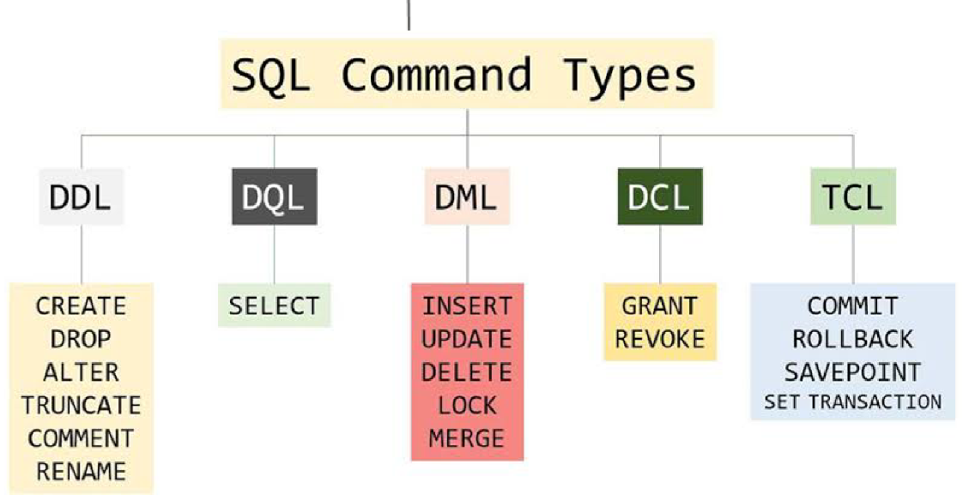
DDL(Data Definition Language): DDL changes the structure of the table, like creating, deleting, altering a table..etc
-> all the command of DDL are auto committed that means it permanently save all the changes in DB .
a. CREATE: used to create a new table in db
syntax: CREATE TABLE TABLE_NAME(COLUMN_NAME DATATYPES[…,]);
EX: CREATE TABLE EMPLOYEE(Name VARCHAR(20),Email VARCHAR2(50), DOB Date);
b. DROP: used to delete both the structure and record stored in the table.
syntax: DROP TABLE;
EX: DROP TABLE EMPLOYEE;
C. ALTER: Used to alter the structure of db. This change could be either to modify the characteristics of an existing attribute or to add a new attribute.
syntax: to add a new column in the table
1. ALTER TABLE table_name ADD column_name COLUMN – DEFINATION;
TO modify existing column in the table
2. ALTER TABLE MODIFY(COLUMN DEFINATION…);
EX: 1. ALTER TABLE stu_details ADD (ADDRESS VARCHAR2(20));
2. ALTER TABLE stu_details MODIFY (NAME VARCHAR2(20));
d. TRUNCATE: used to delete all the rows from the table and free up the space containing in table.
syntax: TRUNCATE TABLE table_name;
ex: TRUNCATE TABLE employee;
DML(DATA MANIPULATION LANGUAGE): used to modify the database, it is responsible for all the form of changes in the data.
->DML is not auto-committed that means it can’t permanently save all the changes in db, they can rollback.
a. INSERT: INSERT statement is SQL query . IT is used to insert data into row of a table.
syntax:
1.INSERT INTO table_name
2. (column1, col2, col3,…..,col N)
3. VALUES(value1, val2, val3,…., val n);
or
1.INSERT INTO table_name
2. VALUES(value1, val2, val3,…., val n);
ex: INSERT INTO phone(Year, Model) VALUES(“2025”, “Iphone17”);
b.Update: used to update or modify the value of column in table.
syntax: UPDATE table_name SET[[column_name1= value1,...column_nameN = valueN] [WHERE CONDITION];
For example: 1. UPDATE students
2. SET User_Name = 'Sonoo'
3. WHERE Student_Id = '3'
c. DELETE: It is used to remove one or more row from a table.
Syntax: 1. DELETE FROM table_name [WHERE condition];
ex: 1. DELETE FROM phone
2. WHERE MODEL="Iphone17"
DCL(DATA CONTROL LANGUAGE): used to grant and take back authority from any database user.(manages the access controls)
a. Grant: It is used to give user access privileges to a database.
Ex: GRANT SELECT, UPDATE ON MY_TABLE TO SOME_USER, ANOTHER_USER;
b. Revoke: It is used to take back permissions from the user.
EX: REVOKE SELECT, UPDATE ON MY_TABLE FROM USER1, USER2;
TCL(Transaction Control Language): TCL commands can only use with DML commands like INSERT, DELETE and UPDATE only. These operations are automatically committed in the database that's why they cannot be used while creating tables or dropping them.(manages transactions)
a. Commit: Commit command is used to save all the transactions to the database
b. Rollback: Rollback command is used to undo transactions that have not already been saved to the database
c. SAVEPOINT: It is used to roll the transaction back to a certain point without rolling back the entire transaction.
DQL(Data Query Language): used to retrieve the data from the database.
SELECT: It is used to select the attribute based on the condition described by WHERE clause.

